CSC630-Computer Graphics Design.
Project #3
Dr. Kroll

The Amazing Maze

Delfin Rojas
George Sellas
Anthony dela Calzada
Carlos Ferreira

1. Introduction

This project will focus mainly in developing a 3D MAZE game. This will be an impressive maze where the player will have a chance to walk around a series of different paths through three dimensional walls. The goal is to reach the end of the path.
The amazing part of this game is expected to be the 3D feel that is given while the player rolls the ball down the path. This scenario attempts to engage the player because it will make him feel good; it will make him feel like he’s playing a hot high tech maze game-an amazing one which is made out of 3D walls and floors-maybe ceilings too if time permits.
We had discussed some of the challenges that our group could face while developing this game. Probably the main challenge seems to be the application of special textures to the walls and floors. This will need to happen simultaneously while the ball moves down the aisles. Another challenge seems to be the different choices of difficulty levels used to traverse the maze.
We feel very confident that we will be able to figure out how to overcome these difficulties. We will develop the final product on time and in good working order.
In the end, we hope to have an amazing and engaging 3D maze game that will make the players screaming for more.
The following image serves as an inspiration for a possible look of our amazing game, although we are not sure how similar we can get.

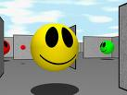

2. Design and Architecture

2.1 Scenes
The project team agreed to organize the code in sections that are called “scenes”. The different scenes can be thought of a collection of actions and content which can be grouped together to offer some specific functionality.
Below is a diagram that depicts the navigation beginning at the “Startup Scene” and following the chosen paths to the “Credits”, “GamePlay”, “Demo” and “Instructions” scenes.
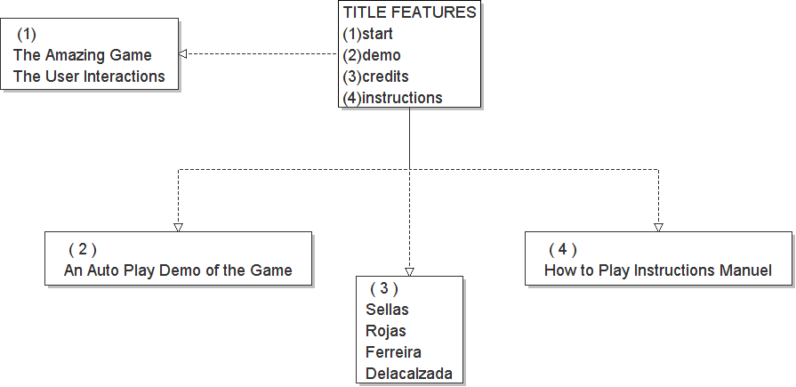

2.2 Background Music
An array of varied song selections will be played while the user goes through the intricate holes and walls. The scenario is made out of selected textures and coordinated colors so that a greater realism is achieved when the images of the maze appears on the computer screen.

2.3 Demo Mode
The Demo scene (demo mode) will auto play the game quickly so that the user can have some idea of what to expect. If the user needs some help on what to do then he/she might decide to take a look at the instructions on how to do it.
And lastly the names of the team members appear if the Credits scene is pulled up.

2.4 Third Party Libraries
The following third party libraries were used in the project:
- OpenGL
- CPW 1.0b for OpenGL window helper functions
- Boost 1.34.1 for smart pointers and generic function binding.
- DevIL 1.6.8 to load textures from JPEG, BMP, PNG and other image files.
- FreeType 2.3.5 for drawing TrueType fonts.
- Audiere 1.9.4 for playing audio files in MP3 and other formats.

3. Gameplay

TODO: give a walk through the game, what keys to press, etc. Screenshots of the game…

4. Additional Information

4.1 Project Hosting
Our project is hosted as an open source project on Google Code. The project is licensed under the "New BSD License".
The project homepage is located at: http://code.google.com/p/amazing-maze/
To checkout a read-only copy of the project source anonymously over HTTP use the following SVN details:
svn checkout http://amazing-maze.googlecode.com/svn/trunk/ amazing-maze-read-only

